CLASS TIMETABLE VIEWER
@CREATIVITY THINK (9483175986/7019689991)

ABSTRACT:
Class Timetable Viewer is a web-based static application designed to provide students and learners with a simple interface to view class schedules. The platform allows users to browse timetables by class or section without requiring backend connectivity. Developed using HTML and Bootstrap, the system ensures a responsive, clean, and lightweight user experience suitable for schools, coaching institutes, or individual students who only need to access schedule information..

INTRODUCTION OF THE PROJECT:
Timetable management and access are essential for students and educational institutions. Traditional methods often involve printed schedules or scattered digital files that are inconvenient to access. Class Timetable Viewer addresses these challenges by providing a web-based static interface where timetables are clearly presented and easily accessible. By focusing on simplicity and clarity, the application ensures that users can quickly find schedule information without navigating complex systems..

PROJECT OBJECTIVES:

• Provide an easy-to-use interface for viewing class timetables
• Allow browsing of schedules by class or section
• Ensure a lightweight, fast-loading static website
• Maintain responsive design for various devices using Bootstrap
• Avoid dependency on backend systems or databases
• Provide a professional and visually clear timetable layout
• Reduce confusion and improve access to class schedules
• Enable quick updates by directly editing code/files

PROBLEM OF THE STATEMENT:
Students and learners often face difficulties accessing class schedules due to scattered information or outdated printed timetables. Existing digital solutions may be complex or require backend systems that are unnecessary for simple viewing purposes. Class Timetable Viewer solves this problem by providing a lightweight, static, and responsive web interface that presents timetable information clearly, making it easy for users to browse schedules efficiently..

MOTIVATION OF THE PROJECT:
• To offer a fast and simple method to access class timetables
• To reduce dependency on printed schedules or PDFs
• To enable quick browsing by class or section
• To provide a visually clear and responsive design
• To simplify schedule updates for administrators (direct code edits)
• To create a low-cost, lightweight solution suitable for small educational setups
• To ensure accessibility across multiple devices without backend requirements

BLOCK DAIGRAM OF PROJECT:

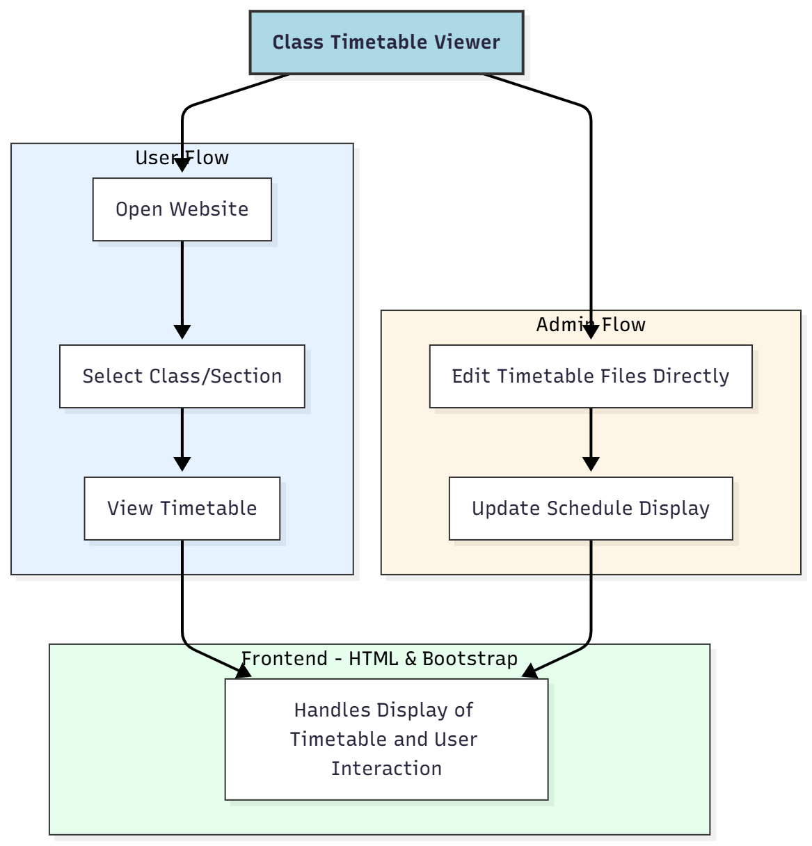

WORKING OF THE PROJECT:
Users open the website and select their class or section from the interface. The timetable for the selected category is displayed immediately using static HTML tables and styled with Bootstrap for readability and responsiveness. Since the project is static, all timetable updates are made by administrators directly in the HTML or CSS files. No backend server or database is required, ensuring fast load times and low maintenance..

SOFTWARE REQUIREMENT:
- Backend:
  - Python 3.x
  - Django
  - Django REST Framework
  - SQLite/PostgreSQL
- Frontend:
  - Node.js and npm
  - React.js
  - Axios
- Development Tools:
  - Visual Studio Code
  - Postman (for testing APIs)
  - Git/GitHub (for version control)
- Server/Deployment (Optional):
  - Gunicorn, Nginx, or Heroku/AWS for hosting

ADVANTAGES OF THE PROJECT:

• Fast-loading static interface
• Easy to browse timetables by class or section
• Fully responsive design with Bootstrap
• Low-cost development and maintenance
• No backend dependencies required
• Simple update process for administrators
• Suitable for small-scale educational use
• Accessible on multiple devices without installation

APPLICATIONS OF THE PROJECT:
• Schools and colleges
• Coaching institutes and tuition centers
• Students seeking quick access to schedules
• Educational websites displaying timetable information
• Low-cost internal educational tools

REFERENCES:

- Django REST Framework Documentation — Django Software Foundation. Django Documentation. Available: https://docs.djangoproject.com/
- Django REST Framework. DRF Documentation. Available: https://www.django-rest-framework.org/
- React. React Official Documentation. Available: https://reactjs.org/docs/getting-started.html
- Redux. Redux Documentation. Available: https://redux.js.org/introduction/getting-started
- PostgreSQL Global Development Group. PostgreSQL Documentation. Available: https://www.postgresql.org/docs/
- MySQL. MySQL Reference Manual. Available: https://dev.mysql.com/doc/
- Git. Git Documentation. Available: https://git-scm.com/doc
- Node.js. Node.js Documentation. Available: https://nodejs.org/en/docs/
- Axios. Axios Documentation. Available: https://axios-http.com/docs/intro
- Socket.io Documentation – https://socket.io/docs/

